Contents
Getting Started with SQL Developer 1
Creating connection profiles 3
Using SQL Worksheets 5
Exporting the results 6
Navigation 8
Entering the database 8
Tables and Views 9
Finding the right view 10

Additional Guidance
Knowledge Article: not yet written
HOW TO - Manage Reports - Access Permissions within HR Reporting.docx
HOW TO - Manage Reports - Change Processes in OSM.docx
HOW TO - Manage Reports - HR Reporting Environments.docx
HOW TO - Manage Reports - Parameters.docx
HOW TO - Manage Reports - Release and Deployment.docx
HOW TO - Manage Reports - Shared Data Sources.docx
HOW TO - Manage Reports - Shared Datasets.docx
HOW TO - Manage Reports - Troubleshoot Common Errors.docx
HOW TO - Manage Reports - Visual Studio Basics.docx

This document provides information that you will need when working in Oracle SQL Developer, including how to launch the application, how to navigate around it, and an explanation of commonly-used terms. This is not a process document so much as a “contextual information” document which you may find useful when you initially begin creating and editing reports in SQL Developer.

Getting Started with SQL Developer
Before you can create or edit reports, you will need to launch the Oracle SQL Developer application and connect to the PeopleXD database you wish to query.

SQL Developer is a remote desktop application. You can find it in your Start menu under “CONNECT Remote Services (RADC)”:

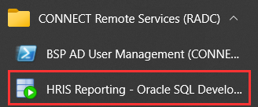

Double-click the entry in your Start menu to launch SQL Developer, and enter your CONNECT login details when prompted – these are necessary in order to access the CONNECT Remote Desktop:

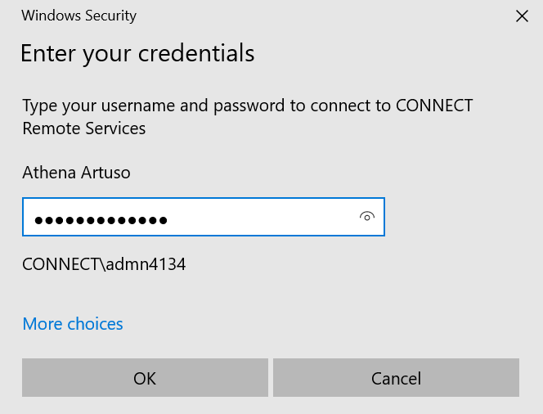

After a short wait, the SQL Developer splash screen will appear, and the application will load:

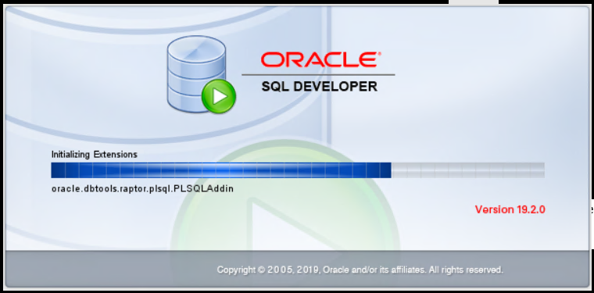

You’ll land on the Welcome Page, which contains links to any databases to which you have previously connected, as well as links to Oracle resources for SQL Developer users. The only thing you’ll generally use here is the Database Connection pane:

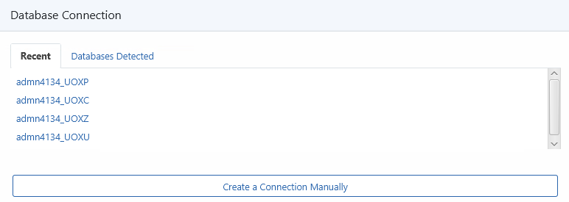

If you have existing database connections, you can simply click on the database to which you wish to connect, and SQL Developer will open a worksheet for you in a new tab, where you can begin querying the database.

If you’ve never used SQL Developer before, you will need to create the database connections you require. This is done by setting up something called a connection profile. See below for details.

Creating connection profiles
To create a connection profile, click the link on the Welcome Page to “Create a Connection Manually”:

A pop-up window will open. Populate it as described below.

Field | Value | Notes
Name | The name you want to assign to the database connection. | This value can be anything you like, but it’s helpful to include the name of the PeopleXD database to which you are connecting, e.g. UOXP.
Database Type | Oracle | Do not change this.
Authentication Type | Default | Do not change this.
Username | Your SSO, e.g. ADMN4134. | This field isn’t case-sensitive, so you can enter your SSO in either UPPER or lowercase.
Password | Your HR Reporting password. | Your HR Reporting password is the password you will use to log into the PeopleXD database in SQL Developer. If you have different passwords for different environments, e.g. one for UOXP and another for UOXU, be sure that you input the correct password in your connection profile!
Role | Default | Do not change this.
Save Password | Tick this box if you want to save your password. | This is optional.
Connection Type | Basic | Do not change this.
Hostname | UOXP - cwocm01.corehr.com  UOXU, UOXC or UOXZ - pwocm01.corehr.com | This value varies depending on which PeopleXD database you are connecting to. Be sure to select the appropriate Hostname from the list given here. Notice that the “non-production” environments all share a host, while UOXP has a different host.
Port | 1521 | Do not change this.
SID | Deselect this radio button. | When you deselect the radio button, the field to the right will be greyed-out.
Service name | Select this radio button and enter the appropriate service name from the list below:  UOXP - uoxp_be.corecloud.local  UOXU - uoxu_be.corecloud.local  UOXC - uoxc_be.corecloud.local  UOXZ - uoxz_be.corecloud.local | This value varies depending on which PeopleXD database you are connecting to. Be sure to select the appropriate Service Name from the list given here.

You can test your new connection profile by clicking the “Test” button at the bottom of the pop-up window:

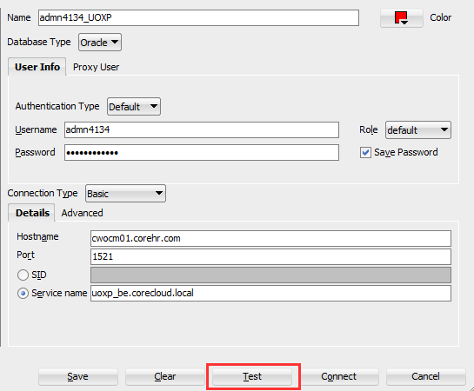

A little progress window will open while SQL Developer tries to contact the database:

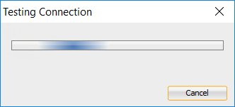

If you haven’t got the correct details for your connection profile, an error message will be displayed in the left-hand corner of the pop-up window:

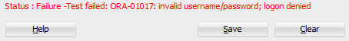

You’ll need to check your details and correct the error, then test the connection again to see if a database connection can be established. If your connection profile has all the necessary details, SQL Developer will confirm that it can connect to the relevant PeopleXD database:

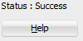

Once you’ve successfully passed a connection test, click “Save” to save your new connection profile. The list of your connection profiles can always be accessed from the Connections pane on the left side of the screen:

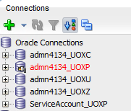

Double-click the connection profile you wish to use and SQL Developer will connect to the PeopleXD database and open a worksheet for you in a new tab, where you can begin querying the database.

You are now ready to begin working in SQL Developer!

Using SQL Worksheets
In order to run reports in SQL Developer, you need to use a worksheet. A worksheet is a page where you write (or copy-paste) the SQL code that you’ll use to query the PeopleXD database. When you launch SQL Developer and connect to a database, SQL Developer opens a worksheet for you automatically in a new tab:

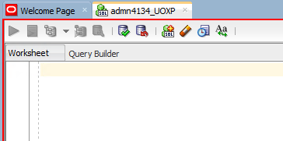

If you’re building a new report (or simply running a small query of some kind), you can simply type your SQL code into the worksheet. If you’ve got the SQL code for an existing report, you can paste it into the worksheet.

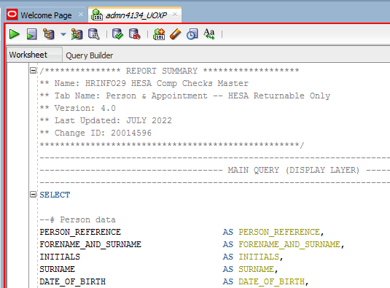

Once you’ve got your code in place, click the little green arrow at the top of the worksheet to execute the code:

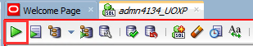

SQL Developer will read the code you’ve entered in the worksheet and will query the PeopleXD database for the information you’ve requested. This may take some time, depending on how complicated the query is, so you might see this progress bar whilst SQL Developer works:

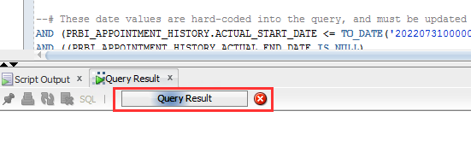

Once SQL Developer has finished executing the code, the results of the query will be displayed in the Query Result pane at the bottom of the screen.

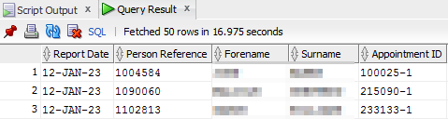

Exporting the results
You may wish to export the results of your SQL query to an Excel file for further analysis. To do this, right-click anywhere in the Query Results pane and select “Export…” from the pop-up menu:

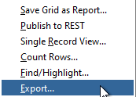

The Export Wizard will open. You need to specify what file format you wish to export the results to, and where on the network you want the export to be saved. In the “Format” field, select “csv”, and in the “File” field, enter the file-path for the network location to which you are exporting the results:

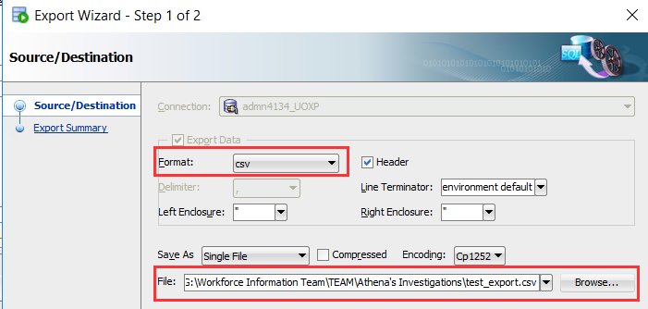

 | Note: Never export results to the Desktop or C:\ drive.  SQL Developer is a remote desktop application – you would be exporting results to the remote desktop, not to your own PC! This is a security risk. It also makes it very difficult to access the file once it’s finished exporting!

Click “Next >” and then “Finish” to exit the Export Wizard.

SQL Developer will begin exporting the results to a .csv file. You can view the progress of the export process in the Task Progress pane at the bottom of the screen:

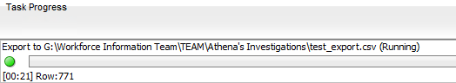

If you can’t see the Task Progress pane, you might need to switch it on. You can find it in the View menu:

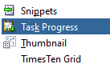

It’s a useful tool, especially if you’re exporting a very large result-set comprised of thousands of rows, as it allows you to check whether the export process is still running. It also provides a running count of how many rows of data have been exported, which may enable you to estimate when the export should be finished (e.g. if you know there are approximately 1,000 rows of data and the Task Progress pane shows that 500 rows have been exported in 30 seconds, you can safely assume that the remaining 500 rows will be exported in the next 30 seconds).
The Task Progress pane will go blank once the export process is complete.

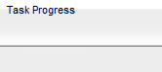

Navigate to the location to which you exported the result-set to check that the file has been saved there as expected:

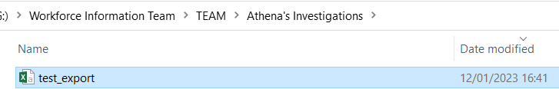

You’ve now successfully run a SQL query and exported the results to Excel!

Navigation
Working in SQL Developer means working with the contents of the PeopleXD database to which you are connected. This section will help you navigate around the database to find the items you want to report on.

Entering the database
To start, head to the Connections pane on the left side of the screen.



Click the (+) symbol to expand the connection in which you’re interested. You will get a very long list of folders to explore, here; the relevant one is right at the bottom of the list, called Other Users.

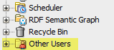

Right-click on the folder and select the option to “Apply Filter…”:

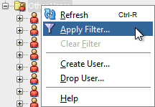

The Filter pop-up will appear. Set the filter to “SCHEMA = COREHR”:

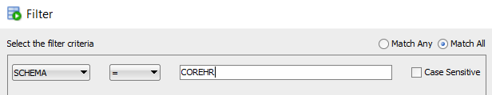

Click OK to apply the filter. The Other Users folder will now only show the sub-folder titled “COREHR”:

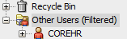

This folder is the PeopleXD database. Click the (+) symbol next to the folder to expand it. You have now entered the database and can explore its contents. The key items here are the sub-folders called “Tables” and “Views”:

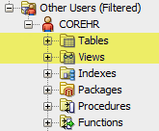

Tables and Views
When you use SQL Developer to run reports, you pull data from PeopleXD’s database tables and database views. A brief explanation of the differences between these things is given here.

Tables are datasets organised by columns and rows. The columns are the “attributes” of the table – things like PERSON_REFERENCE and SURNAME. The rows are where the “records” are stored.

 | PERSON_REFERENCE  (Attribute1) | SURNAME  (Attribute2)
Row1 (Record1) | Data | Data
Row2  (Example) | 2367246 | Artuso

Views are “virtual” tables which are built on top of the actual database tables. A view is often just a subset of data from a single table, but views can also combine data from two or more tables.

Example 1: The image below shows a view of data that comes from a single table. In this case, the view is composed of two columns from the blue table:

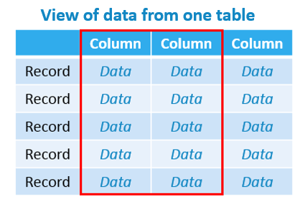

Example 2: The next image shows a view composed of data from multiple tables – one column from the purple table and two columns from the blue table. These columns are combined to create the view:

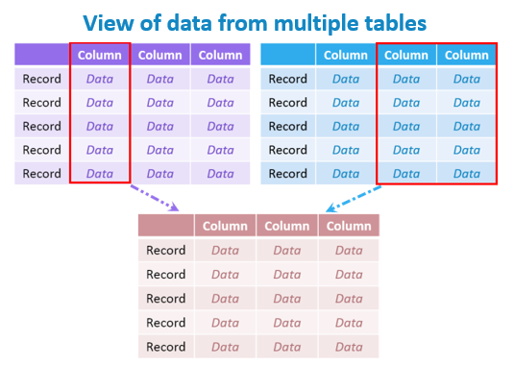

Because views can contain data from multiple tables, they are more dynamic than tables. You will normally use views when writing reports in SQL Developer.

Finding the right view
PeopleXD’s database contains hundreds of tables and views, so it’s helpful to have an idea of what kind of data you want before you start exploring. You can then filter the “Tables” or “Views” sub-folder for the keywords in which you’re interested.

 | PeopleXD’s views follow relatively strict naming conventions which identify what kind of data is contained within each view. The guidance below is intended for use when exploring views. PeopleXD’s tables do not have naming conventions, and are a bit more difficult to search, so will not be covered here.

If you want to see… | Filter “Views” for…
Personnel data | PRBI_%  - This is the prefix for all personnel data-related views within PeopleXD. It stands for “PeRsonnel Business Intelligence”.
Recruitment data | RTBI_%  - This is the prefix for all recruitment data-related views within PeopleXD. It stands for “RecruiTment Business Intelligence”.
Payroll data | PABI_%  - This is the prefix for all payroll data-related views within PeopleXD. It stands for “PAyroll Business Intelligence”.
Time-management data (absence, sickness, timesheets) | CTBI_%  - This is the prefix for all time-management data-related views within PeopleXD. It stands for “Core Time Business Intelligence”.
HESA data | HEBI_%  - This is the prefix for all HESA data-related views within PeopleXD. It stands for “HESA Business Intelligence”.
Lists of values (reference data) | %LOV%  - PeopleXD’s reference data is largely contained within lists of values (LOVs), so filtering the “Views” folder for this term will bring back most of the reference data set up in the system.

To filter the “Views” sub-folder, right-click it and select the option to “Apply Filter…”:

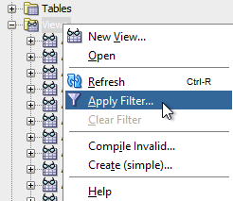

The Filter pop-up will appear. Set the filter to “NAME LIKE” and enter the keyword by which you wish to filter the folder.

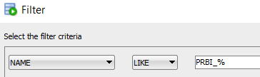

Click OK to apply the filter. The “Views” sub-folder will refresh and you will see a list of available views which match your search term:

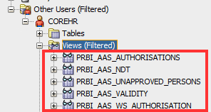

 | The percent (%) symbol is a wildcard. If you want to search for all views which contain the word “appointment”, you could search for “NAME LIKE %APPOINTMENT%”:  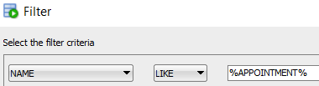  The percent symbols here just indicate that your search should return all views containing the word “appointment”, regardless of whether that word appears at the beginning, the end, or in the middle of the view name. Here are some of the results:  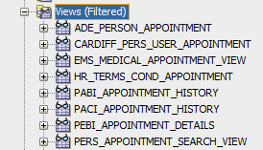

Once you’ve located the view in which you’re interested, click the (+) symbol next to the view folder to see the items contained within that view:

